Gamification of the workplace: An Analytical Viewpoint

Gamification of the workplace refers to creating a game-like environment in corporate or other work based settings. An example of this is the now popular employee of the month badge which motivates employees to be the best at work to win it. A completely gamified workplace comes with the expectation that employees will be on their toes and excited to work in pursuit of recognition and honour among their colleagues. The question follows, to what extent does the workplace need to be gamified to achieve this effect and whether it is truly effective.
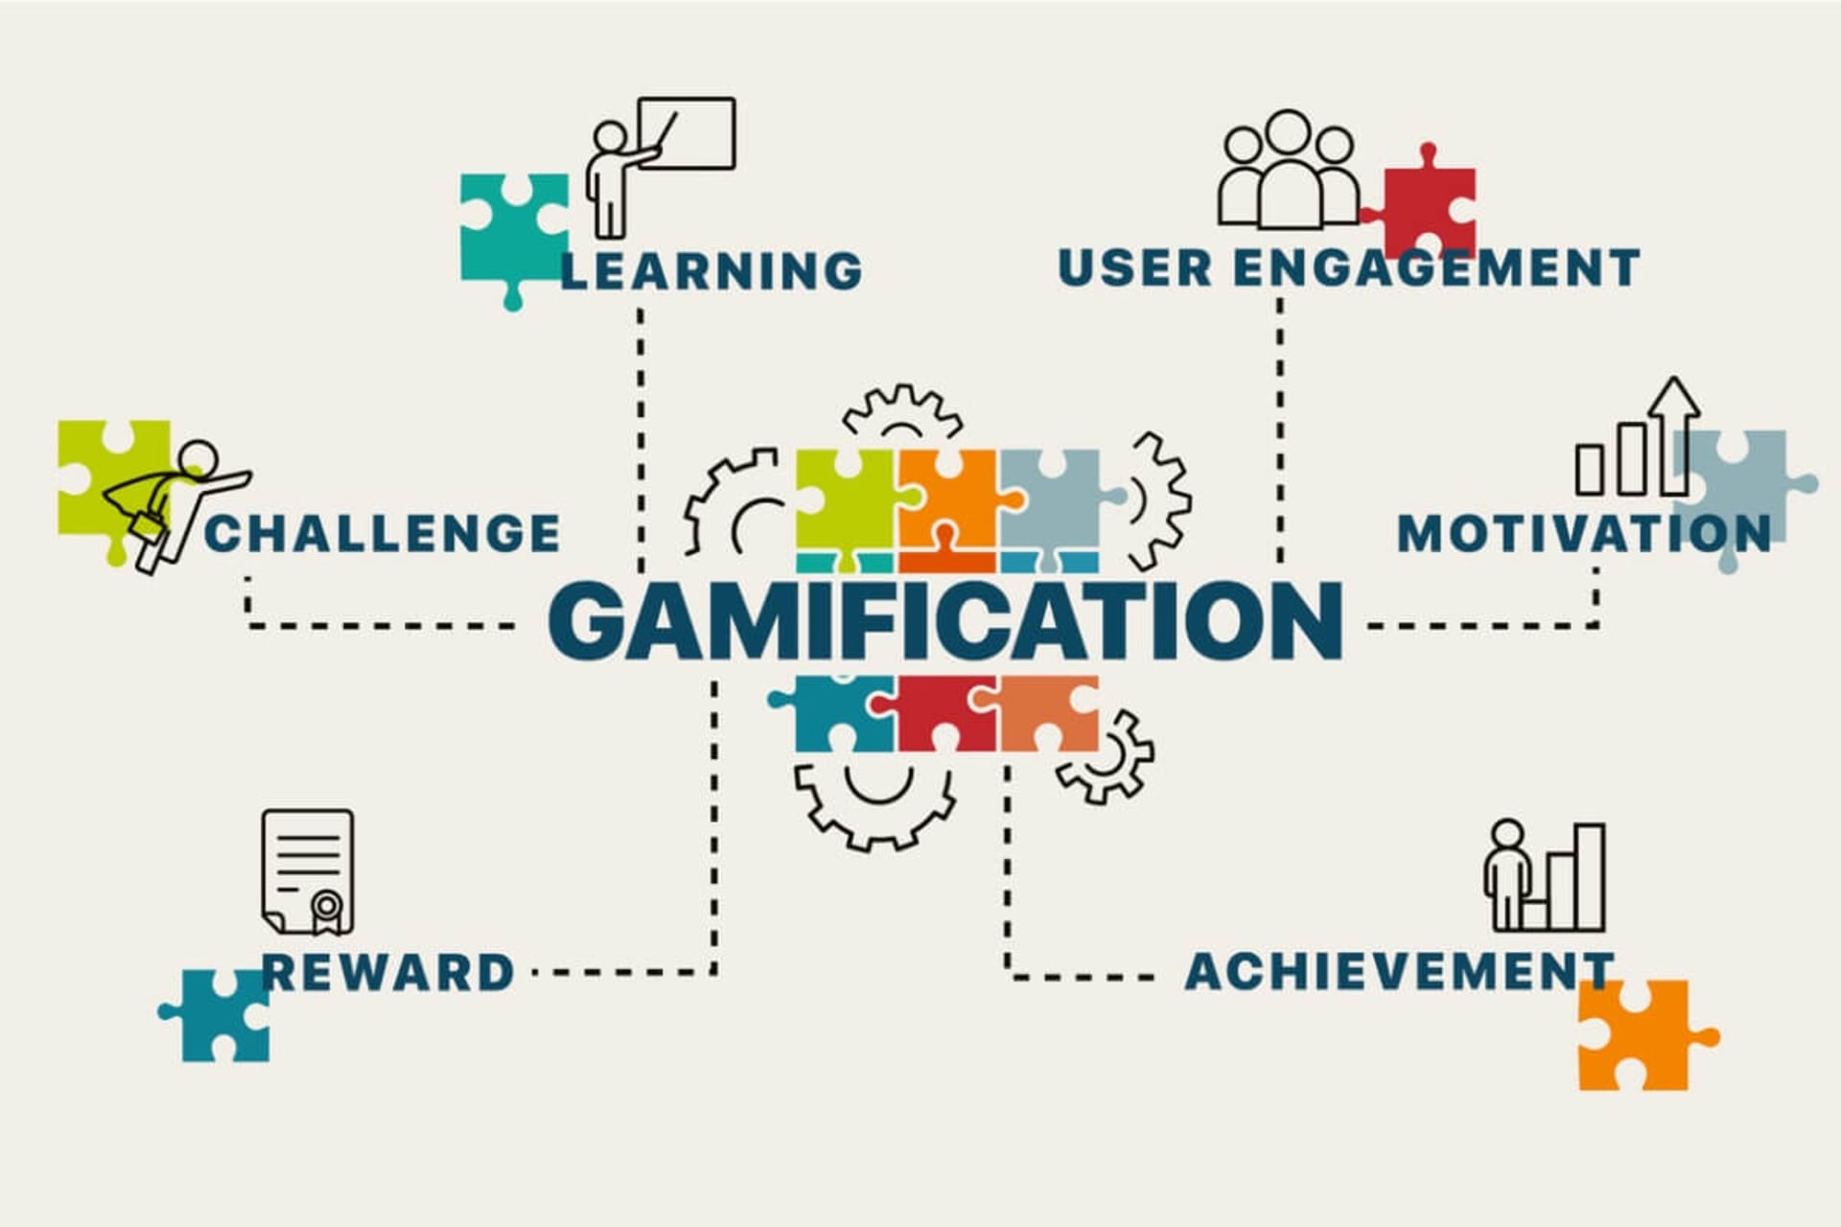

A gamified workplace can create happy and productive employees. This can be proven via our brain’s love for rewards causing it to release dopamine. This can also in practice be seen in companies like Microsoft who implemented a dynamic program that rewarded agents with points and badges and offered microlearning and personalized goals in a fun and engaging way. The program led to a 12% drop in absenteeism, an increase of 10% in terms of calls per shift, and after implementation, 78% of agents said they felt more empowered and ready to do better at their work (Centrical, 2025). The case of Microsoft highlights the fact that the workplace does not need to be completely transformed in order to achieve this effect but rather an alternative approach is what was needed to be considered.

A counterpoint to such a measure however is the fact that the gamified workplace can lose its appeal and stale out in addition to the fact that the incentives provided must actually mean something. For example, just adding a system to recognise the most hard working member in the team and calling it a day can be significant at first but it is only a matter of time until it stops motivating employees. In Microsoft’s case particularly, a point can be made that when employees start to get acclimated to this new system of work, there’s only a matter of time until they start perceiving it as monotonous. This reflects the need to be proactive with measures of this nature to achieve the desired long term effect of employee productivity in addition to the side benefit of improved mental health.

A gamified workplace is futuristic and just ideal for the newer generation grown off of the backs of video gaming and intuitive technology. It can promote a friendly yet competitive work environment in addition to fostering employee productivity in a manner that is both engaging and enjoyable. Corporates looking to implement this measure must be wary of lousy implementation and mediocre incentives in order to actually achieve this long term effect however but if so considered, can be a powerful tool in revolutionizing employee interaction and work output.
At YWP; we aspire to spread awareness towards enhancing employee wellbeing and productivity. We as an organization work consistently towards supporting corporates in wellbeing workshops. 🌟 Join us to make workplaces healthier and more productive for employees. Reach out to us at workplacewellbeingbyywp@gmail.com with any queries or collaboration ideas.

